Dan Murphy

Deborah Pais

Wanming Zhang

MTE 360 Automatic Control Systems

Laboratory 2: PD/PID Control, Steady State Error and Stability Analysis

## Part 1

1 a)

From the PD controlled servo system block diagram:

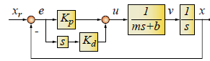

Then,

From Lab 1,

1 b)

From the block diagram, let:

The resulting transfer function is

Since, for an ideal 2nd order system, the transfer function is:

Then relating that to the closed loop system above,

From the design specifications:

In addition, recalling the values from 1 a)

1 c)

The ideal system response and the theoretical response of the PD-controlled system are presented below:

|  |
| --- |
|  |
|  |

Note that the D-controlled system has an additional left-hand plane pole. This increases the overshoot as can be seen in the graphs. Since zeta = 0.8 is fairly close to 1, the ideal system has very little overshoot, with the system response fairly similar to that of a critically damped system. The addition of the additional zero to allow for D-control creates a much higher degree of overshoot. The pole-zero maps presented below show that the systems have identical pole locations, but the derivative controlled system has an additional zero at Kp / Kd = 36.58.

|  |
| --- |
|  |
| C:\Users\Wanming\AppData\Local\Microsoft\Windows\INetCache\Content.Word\pz-dcntrl.png |

1 g)

The graphs for simulated and experimental square wave tracking and smooth trajectory tracking for the PD controller are shown below:

|  |
| --- |
| C:\Users\Wanming\Dropbox\3B\mte360\lab2\lab2_q3f_g\lab2_q3f_plot.png |
| C:\Users\Wanming\Dropbox\3B\mte360\lab2\lab2_q3f_g\lab2_q3g_plot.png |

Similarities/discrepancies b/w simulation and experimental results: [please check over]

* During periods where the position is constant, there is a constant 0.1mm tracking error for the measured result where the tracking error for the simulation is around 0mm.
* The general trends for position and error between the simulated and experimental results are similar. When moving from rest, there is a spike in tracking error. During constant velocity or position, the tracking error is constant.

## Part 2

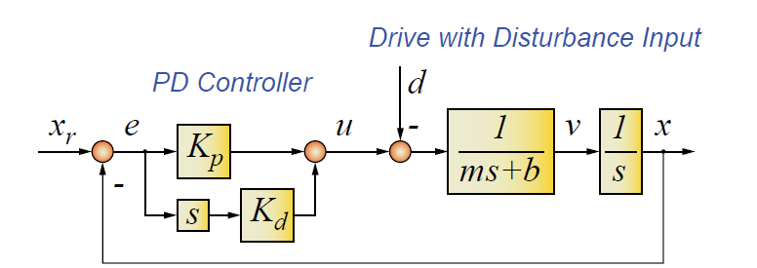

2 a) To express the position as a function of the trajectory command and disturbance:

From the block diagram, let:

Using superposition on PD controlled system with disturbance:

2 b) To express the tracking error as a function of the trajectory command and disturbance:

Using superposition on PD controlled system with disturbance:

2 c) Theoretical expression for steady state error during constant velocity motion:

From Figure 2 in 1g, was observed to be 0.6mm from the tracking error plot during constant velocity between 0.3s and 0.5s.

From 2b,

Due to constant velocity,

Coulomb friction is a represented by a constant value , so

From 1f,

How are the error components are affected by commanded velocity, friction magnitude dc, other parameters, k etc

* As Kp increases, both the error components decrease
* As either as b or v0 increases, increases
* As dc increases, increases.
* The error components are not affected by Kd

2 d) value from part 1f (following error during constant velocity motion)

From 2c,

The average value of Coulomb friction is:

The theoretical value of steady state tracking error in the absence of friction was found in 2c to be:

2 e) rerun with part trajectory from part 1f with friction, overlay sim and exp tracking results (similar to 1g).

* comment on similarity and discrepancy.
* During positive change in position, the simulated and measured tracking error is nearly identical.
* During negative change in position including to rest, the tracking error is lower for the measured result by around 0.1mm.

|  |
| --- |
| C:\Users\Wanming\Dropbox\3B\mte360\lab2\lab2_q2e\lab2e_plot (Figure 3).png |

## Part 3

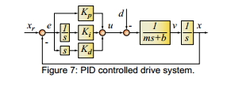

3(a)

Let

and

by inspection

Isolate for x

3(b)

Steady State

3(c) Routh’s Stability Criterion for

|  |  |  |  |
| --- | --- | --- | --- |
|  | 1 |  | 0 |
|  |  |  | 0 |
|  |  | 0 |  |
|  |  | 0 |  |

3(d) Substituting   
 ,, =1.4705

Solving for upper bound of ki:

3 e) How error changes as you modify K? show in graphs similar to part 1g (use 3 diff cases for kp)

* As the value of Ki increases, the average value of tracking error decreases, and the frequency at which tracking error changes from positive to negative increases.
* The frequency at which the system attempts to make corrections increases as Ki increases.
* If Ki > 118, as predicted by the Routh’s stability criterion in 3c, the system becomes unstable (after 1.25s for Ki = 150).
* If Ki < 0, the tracking error will increase to infinity.

|  |
| --- |
|  |
|  |
|  |

3 f) Show simulation and experimental results, plot similar to 1g.

From Routh’s Stability criterion in 3c,

Using a safety factor of 3,

Using this Ki value, the experimental and simulated results are shown below.

Similarities and differences?

* During periods of constant velocity and periods of constant position, the tracking error is around 0 mm for both the simulated and measured result.
* The measured result has a higher spike (around 0.4mm) in tracking error when moving from rest.

|  |
| --- |
| C:\Users\Wanming\Dropbox\3B\mte360\lab2\lab2_q3f_g\lab2_q3f_plot.png |

3 g) overlay experimental from parts 1f and 3f. comment on contribution of integral action.

|  |
| --- |
| C:\Users\Wanming\Dropbox\3B\mte360\lab2\lab2_q3f_g\lab2_q3g_plot.png |

* Does integral control provide better tracking and disturbance rejection?
  + Integral control provides better tracking as the average value of tracking error is lower
  + It also provides better disturbance rejection as evidenced by 0 tracking error at periods of constant position compared to around 0.1mm for the PD controller.
* What are the limitations
  + At certain values of Ki, the system will be unstable…?
* Refer to 2c, 3b, 3c to back up comments

3 h) plot pole-zero maps of PD and PID transfer functions on the same graph (use diff symbols for each)

|  |
| --- |
| C:\Users\Wanming\Dropbox\3B\mte360\lab2\New folder\lab2_3h_plot.png |

* Comment on pole and zero locations (refer to natural freq and damping ratio values)

By referring to the plot and using Matlab functions: damp() and zero(), the natural frequencies, damping ratios, poles and zeroes were found to be the following:

|  |  |  |  |
| --- | --- | --- | --- |
| **PD Controller** | | | |
| *Freq* | *Zeta* | *Poles* | *Zeroes* |
| 50.265 | 0.8 | -40.212 ± 30.159i | -36.585 |
| **PID Controller** | | | |
| *Freq* | *Zeta* | *Poles* | *Zeroes* |
| 34.489 | 0.340 | -11.741 ± 32.429i | -18.293 ± 25.420i |
| 56.943 | 1 | -56.943 |

* How are closed loop pole locations affected by the integral?

## Appendix

1d) Simulink model for PD controller square wave (no friction)

1g) Plot position, tracking error, control signal for PD controller (no friction)

2e) Simulink model for PD controller with friction

* Plot position, tracking error, control signal for PD controller with friction

3d) Simulink model for PID controller with friction

* Graph of simulation of smooth trajectory from Simulink model

3e) Graphs of different Ki values